GEOGRAPHIC DATA VISUALIZATION USING TABLEAU

Literacy Rates of Indian States and Union Territories Census 2011

Project type | Micro Project – Data Exploration and Visualisation
Visualization tool | Tableau Desktop / Tableau Public
Dataset | 35 administrative units: 28 states and 7 union territories
Main output | Point map, literacy-rate bar chart, and combined dashboard
Repository suggestion | tableau-literacy-rate-visualization-india

Project overview
The project uses geographic visualization to compare Census 2011 literacy-rate percentages for Indian states and union territories. The map provides geographic context; the bar chart provides a clearer comparison of exact values; the dashboard combines both views.

Dataset fields

Field | Meaning / use
State_or_UT | Name of the state or union territory; main geographic field
Administrative_Unit | State or Union Territory; category for grouping
Country | India; geographic context
Literacy_Rate_Percent | Numeric literacy-rate percentage; main measure
Census_Year | Census year (2011)
Source | Dataset source/reference text
The uploaded report describes 35 records, comprising 28 states and 7 union territories. The literacy values range from 61.8% to 94.0%.

Prepare the dataset
  - Locate the CSV file used for the project. It should contain the six fields listed above and 35 data rows.
  - Open the CSV in Excel or a text editor and check that the first row contains the column names.
  - Confirm State_or_UT and Administrative_Unit are text fields; Literacy_Rate_Percent is numeric; Census_Year is a whole number.
  - Check for blank cells and duplicate rows. The uploaded report records zero missing cells and zero exact duplicate rows.
  - Keep the country field as India. Do not silently replace the Census 2011 administrative units with newer boundaries.
  - Save a clean copy as `india_literacy_2011.csv` so it is easy to identify when connecting Tableau.

Connect the CSV to Tableau
  - Open Tableau Desktop or Tableau Public.
  - On the start page, under Connect, choose Text File and select `india_literacy_2011.csv`.
  - In the Data Source page, inspect the preview and verify that all six column names appear.
  - Check the data types shown by Tableau. If Literacy_Rate_Percent is read as text, change its data type to Number (Decimal).
  - Open a worksheet (for example, Sheet 1). Confirm that the data pane shows State_or_UT and Literacy_Rate_Percent.

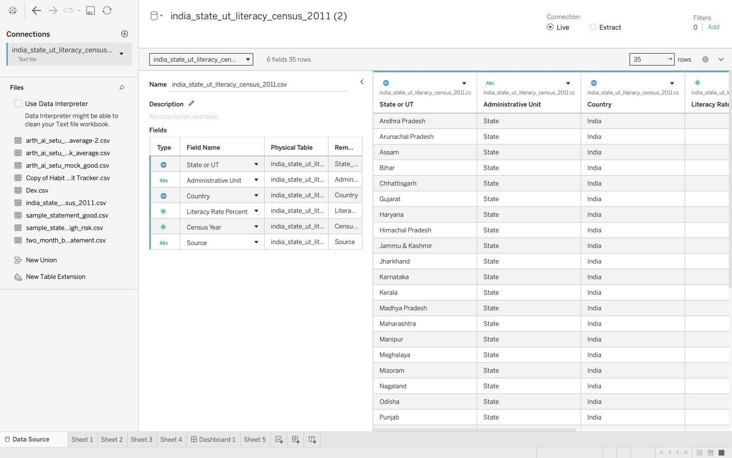

Figure 1. Data-source screenshot extracted from the supplied report (Tableau interface).

Create the point map
  - Open a new worksheet and rename it `Literacy Rate Map`.
  - If Tableau does not recognize State_or_UT geographically, right-click the field and select Geographic Role. Choose the most suitable geographic role available. State/Province is generally the first option to test.
  - Use Country as additional context where available. If needed, create or use a Country field containing India for every row.
  - Double-click State_or_UT or drag it into the view to let Tableau generate a map.
  - On the Marks card, use Circle if a point map is desired.
  - Drag Literacy_Rate_Percent to Color. Optionally drag the same measure to Size to make larger values visually distinct.
  - Drag State_or_UT and Literacy_Rate_Percent to Tooltip so the location name and exact rate appear when a mark is selected.
  - Add a clear title such as “Census 2011 Literacy Rate by State/Union Territory”. Check that the color legend is visible and understandable.

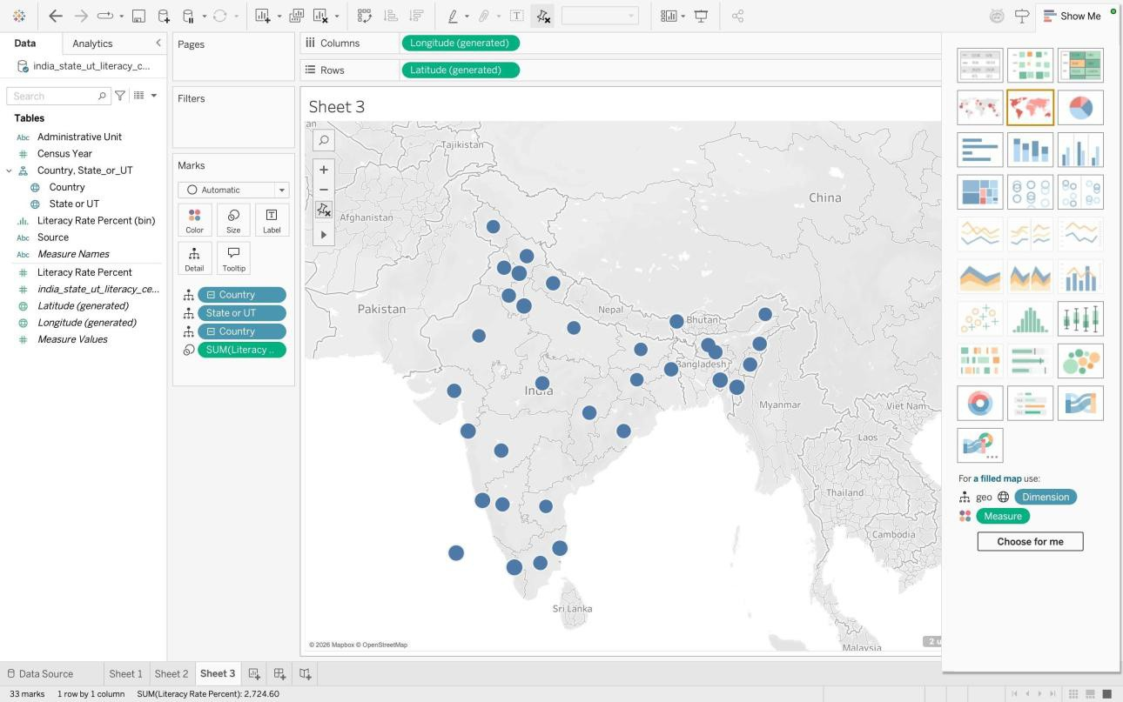
Figure 2. Point-map worksheet shown in the supplied report. The screenshot shows 33 marks and “2 unknown” locations.

Resolve unknown locations
  - Click the “unknown” indicator on the map to inspect the unmatched location names.
  - Check the spellings and historical labels against the 2011 dataset. The uploaded report mentions abbreviations such as “A & N Islands” and “D & N Haveli” as possible causes, but it does not prove which two names failed.
  - Try the full official location name in the data, or edit aliases only when you have verified the correct match.
  - If geographic name matching remains unreliable, use a verified latitude/longitude file and assign those fields to generated Latitude and Longitude in Tableau.
  - Confirm the number of plotted marks after correction. If two records remain unknown, mention that limitation in the report rather than hiding it.

Create the literacy-rate bar chart
  - Create a new worksheet and rename it `Literacy Rate by State UT`.
  - Drag State_or_UT to Rows.
  - Drag Literacy_Rate_Percent to Columns. Check that Tableau uses AVG or the appropriate single rate per unit, not SUM of repeated records.
  - Choose Bar from Show Me, or select Bar in the Marks card.
  - Sort the bars in descending order to make high and low values easy to compare.
  - Drag Literacy_Rate_Percent to Label and turn on Show Mark Labels.
  - Format the axis as a percentage or append a clear “Literacy rate (%)” axis title. Use a readable chart title.
  - Check the chart includes all 35 records and that labels are readable. A horizontal bar chart is recommended when state names are long.

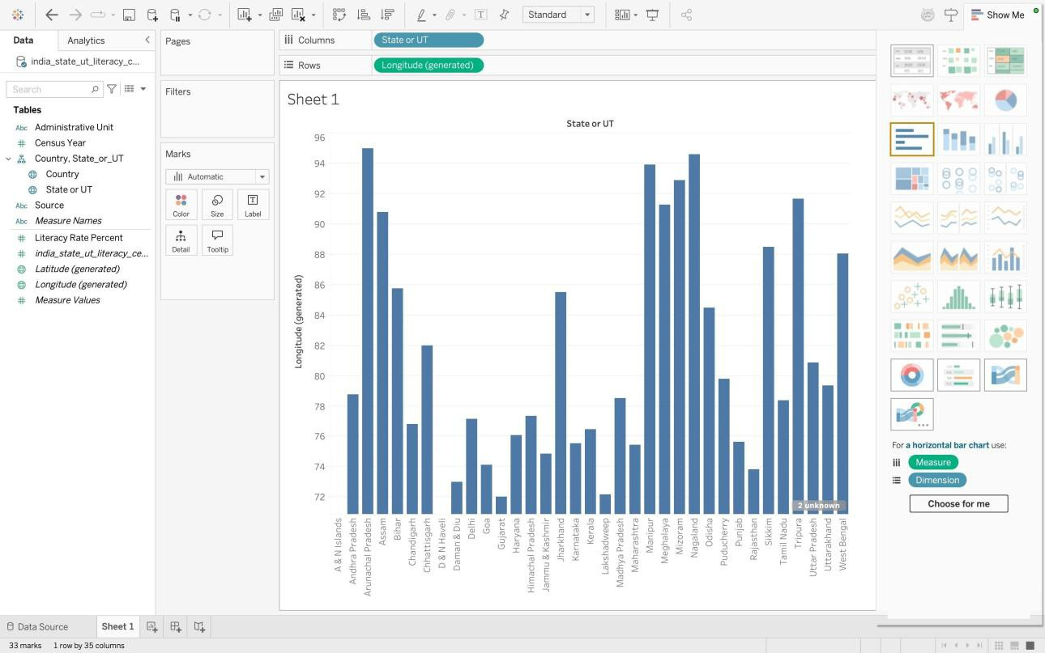

Figure 3. Bar-chart worksheet screenshot extracted from the supplied report.

Build the dashboard
  - Click the New Dashboard icon at the bottom of Tableau.
  - Rename the dashboard `India Literacy Dashboard – Census 2011`.
  - Drag the `Literacy Rate Map` worksheet onto the dashboard.
  - Drag the `Literacy Rate by State UT` worksheet beside or below the map.
  - Place the color legend where it does not take too much space. Adjust the map and chart sizes so state names and map marks are readable.
  - Use the dashboard title to state the topic and census year.
  - If useful, open the worksheet menu on the map or chart and select “Use as Filter” so selecting a mark filters the other view.
  - Test the dashboard by selecting a state or mark, clearing the selection, and checking that the views behave as expected.

A good dashboard uses the map for location context and the sorted bar chart for exact comparisons. Avoid a narrow map, an oversized legend, or unreadable state labels.

Validate and interpret the output

Measure | Value in uploaded report
Number of administrative units | 35
Mean literacy rate | 77.85%
Median literacy rate | 76.9%
Lowest recorded rate | Bihar — 61.8%
Highest recorded rate | Kerala — 94.0%
Range | 32.2 percentage points
States / Union Territories | 28 / 7
These are the descriptive values reported in the uploaded PDF. They describe the 2011 records and are not population-weighted national estimates.
- Check the bar chart includes 35 units.
- Check the highest and lowest labels against the dataset.
- Check the map for unknown locations and do not overstate its coverage.
- Check the title, legend, tooltips, and axis labels are readable.
- Take screenshots only after the final output has been checked.

Save and export your Tableau work
  - Save the workbook using File → Save As.
  - For a portable workbook that includes local data, choose Tableau Packaged Workbook (`.twbx`) if the option is available.
  - Save a screenshot of the completed dashboard as `tableau_dashboard.png`.
  - Export the dashboard or workbook to PDF if your Tableau version offers a suitable export option. Review the PDF to ensure labels are not clipped.
  - Keep the source CSV and final report alongside the workbook. Do not include confidential data or credentials.

Create a GitHub repository and upload the project
  - Open https://github.com/ and sign up or sign in.
  - Click the plus (+) menu and choose New repository.
  - Use the repository name `tableau-literacy-rate-visualization-india`.
  - Enter the description: “Geographic visualization of Census 2011 literacy rates for Indian states and union territories using Tableau.”
  - Choose Public only if you want the project to be publicly visible. Add a README file and create the repository.
  - Open the repository, select Add file → Upload files, and upload the files you actually created.

Suggested repository layout
tableau-literacy-rate-visualization-india/
■■■ README.md
■■■ data/

- ■■■ india_literacy_2011.csv
■■■ screenshots/
- ■■■ tableau_dashboard.png
■■■ workbook/
- ■■■ tableau_project.twbx
■■■ report/
■■■ project_report.pdf
  - Write a commit message such as “Add Tableau literacy visualization project” and click Commit changes.
  - Open the repository page and copy its URL. Add that URL to your project report only after the repository has been created.
Do not claim a GitHub repository has been created until you have actually uploaded the files. Replace the example file names with your real file names.

Publish an interactive dashboard
  - If you want others to interact with the dashboard online, use Tableau Public at https://public.tableau.com/.
  - Sign in and publish the workbook using the available Tableau Public publishing option.
  - Open the published dashboard and copy its public URL.
  - Add the URL to the GitHub README. Confirm the published workbook contains no private data.
GitHub stores project files; Tableau Public hosts an interactive visualization. They serve different purposes.

Final submission checklist
- CSV dataset contains the expected fields and 35 rows.
- Tableau data-source view opens correctly.
- Map and bar chart worksheets are saved.
- Dashboard includes both map and bar chart.
- Unknown locations are resolved or documented.
- Workbook is saved as .twbx when portability is required.
- Dashboard screenshot and final project report are included.
- GitHub repository URL is real and accessible to the intended reviewer.
- All claims and screenshots correctly identify Tableau rather than Power BI.

